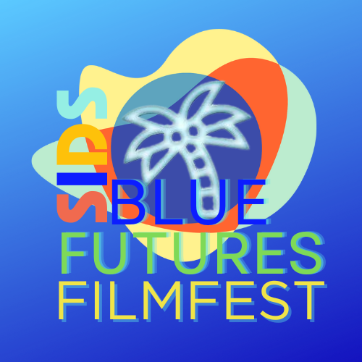

CARIBBEAN FUTURES FORUM & ICS presents
SIDS BLUE FUTURES FILMFEST
in commemoration of UN Conference on Small Island Developing States MAY 24-26th Online.

OUR OCEANS ARE ONE

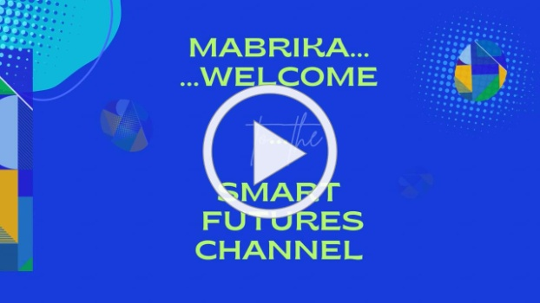

SMART FUTURES channel

FOR IMMEDIATE RELEASE

OUR OCEANS ARE ONE... SIDS Blue Futures Mobile Film Challenge to Showcase Young Film Makers from Small Island Developing States

[Washington DC, April 17, 2024] - The inaugural SIDS Blue Futures Mobile Film Challenge & Festival set to premiere May 24, 2024 will provide a platform for emerging talent from the Caribbean, Pacific Islands, and other small islands worldwide to showcase their creative voices.

"Our Oceans Are One".
The Challenge will require Filmmakers to use the phrase "Our Oceans Are One" in a 3- 10 minute film created on a mobile phone.

Organized in alignment with the UN 4th SIDS Conference (May 27-29) this short film festival aims to raise awareness about environmental concerns unique to Small Island Developing States (SIDS) through the lens of mobile phone filmmaking.

The winning films will be featured on a CARIBNATION TV Special on World Island Day, June 7, 2024.

About the Festival:
Blue Futures Mobile Film Challenge is a pioneering initiative of the Caribbean Futures Forum designed to empower young filmmakers in SIDS to explore and address environmental challenges through the art of filmmaking. Participants will create short films using mobile phones, capturing the essence of their surroundings and highlighting ecological conservation efforts. The festival celebrates the rich biodiversity and cultural heritage of SIDS while raising awareness about pressing environmental issues.

Get Involved!
SIDS Blue Futures Film Shorts invites youth filmmakers from SIDS and beyond to participate in this groundbreaking event. Whether you're a budding filmmaker or an environmental enthusiast, this festival offers a unique opportunity to make a difference and showcase your talent on a global stage.

Creative Director: Majella Mark
Renowned documentary director Majella Mark, known for her work addressing social inequalities and amplifying marginalized voices, will be a featured director at the festival. Mark has a passion for storytelling and advocacy, and She utilizes her creative endeavors to shed light on critical social issues and empower communities through art.

Contact Information
For media inquiries, interviews, volunteering or partnership opportunities, please contact:
BlueFuturesFilmFest@icsdc.org

SIGN UP FOR OUR MOBILE FILMMAKING WORKSHOP

APRIL 27th @ 11AM EDT

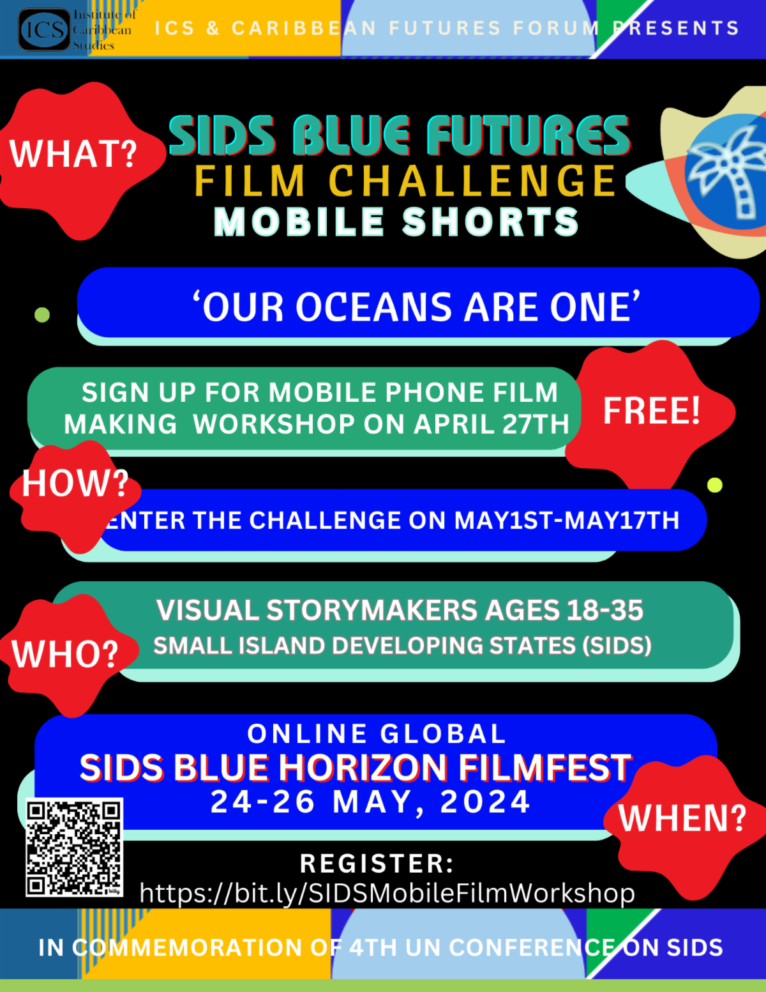

Claire A. Nelson Ph.D.,
Author, SMART Futures For a Flourishing World
Futurist & White House Champion of Change

Founder & President | Institute of Caribbean Studies, Washington DC
www.icsdc.org

&
Chair | National Caribbean American Heritage Month
www.caribbeanamericanmonth.org

Executive Producer | Invest SMART Caribbean &
National Caribbean American Heritage Awards
www.caribbeanheritageawards.org

CONNECT:
https://linktr.ee/drclaireanelson
Skype: Claire.A.Nelson
JOIN MAILING LIST

